Test-run of Program

Display of Main Menu

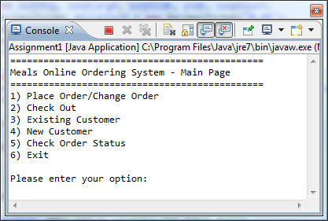

Selection of set meals

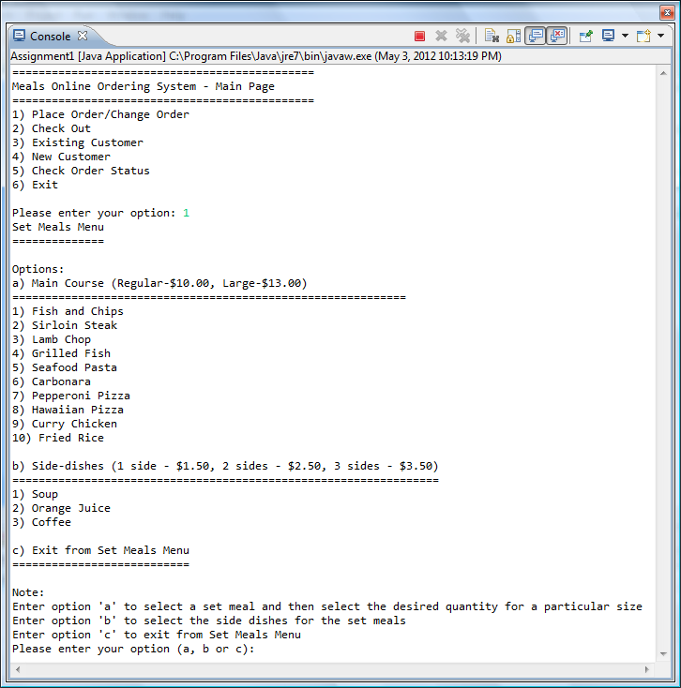

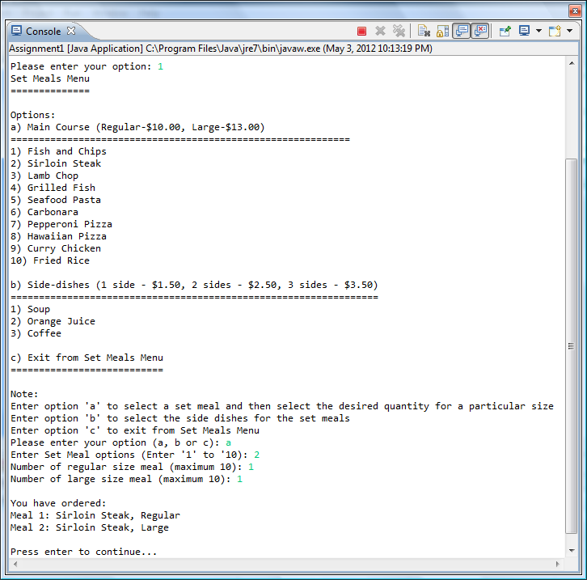

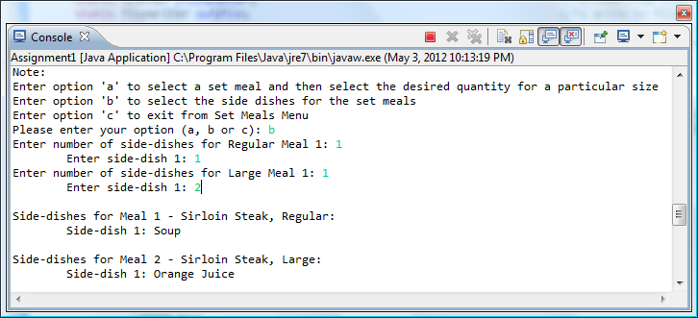

Display of Order Summary

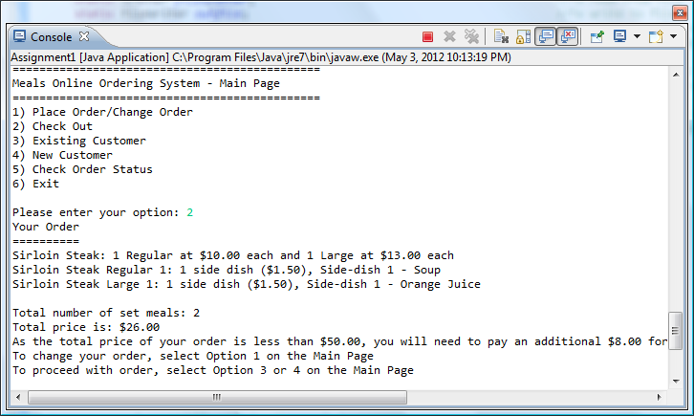

Delivery for Existing Customers

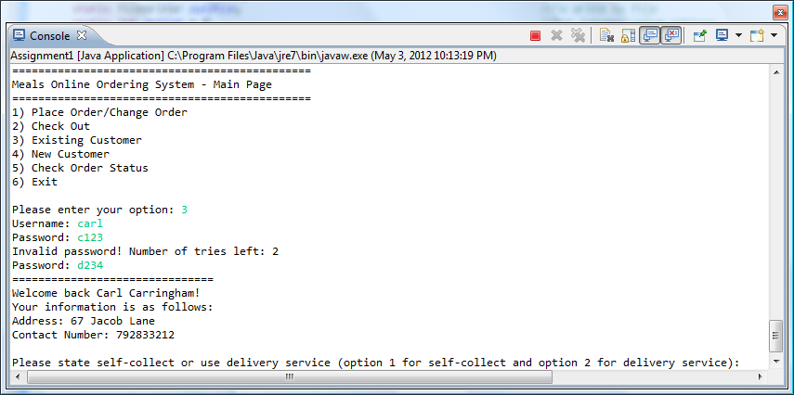

Delivery for New Customers

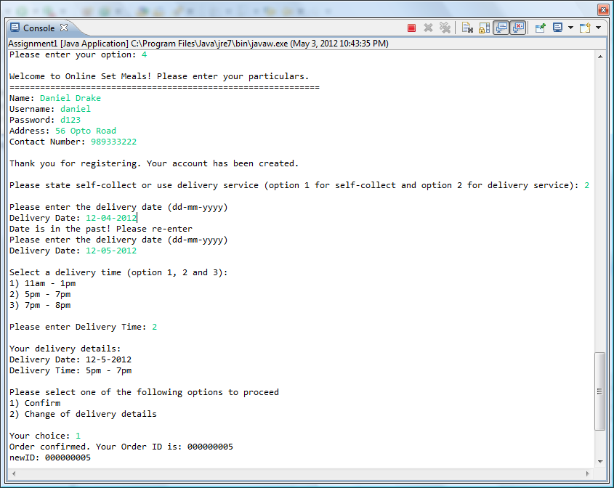

Saving to file

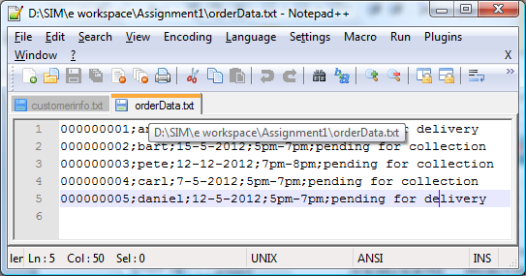

Track order status

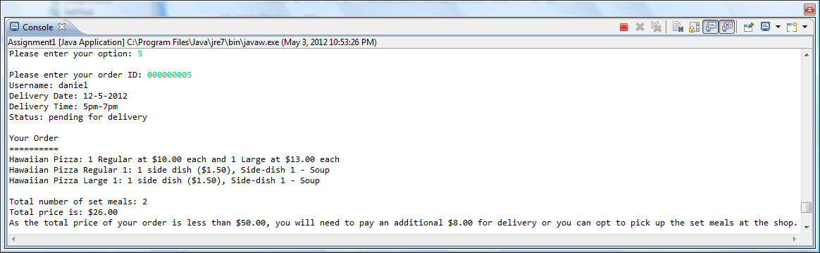

Program Termination

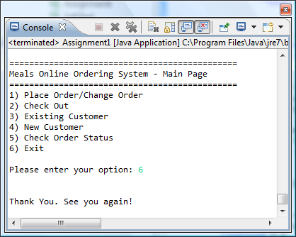

Error Handling

Main Menu Option:

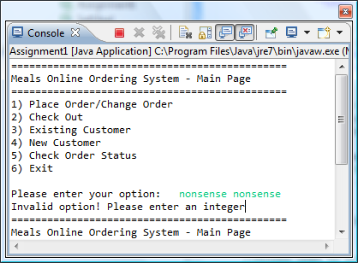 If not an integer

If out of range

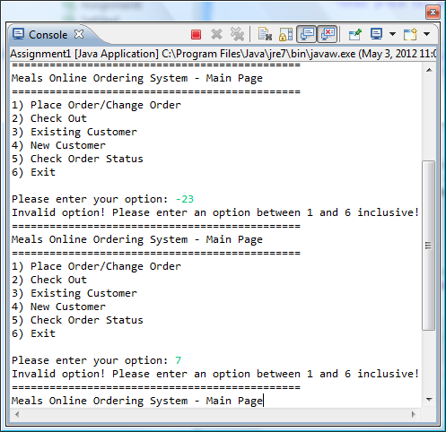

Entering option 2 without placing an order

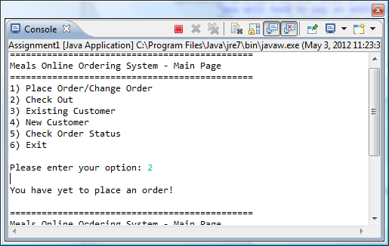

Entering option 3 and 4 without placing an order

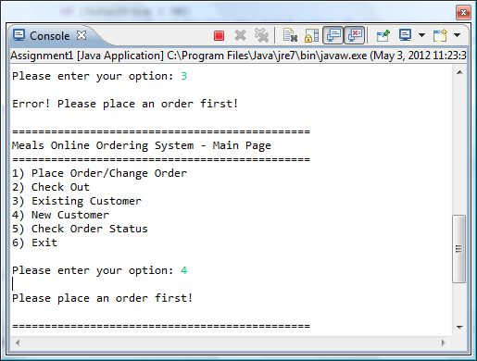

Set Meal Option

1. Must be only one character
2. Must be only ‘a’, ‘b’ or ‘c’
3. Cannot enter ‘b’ unless main course is chosen

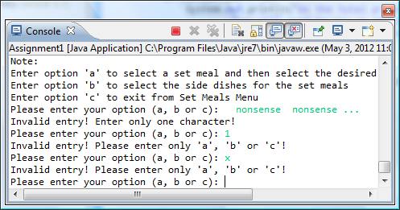

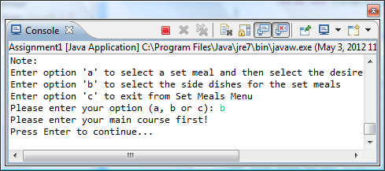

Main Course Option

1. Must be an integer
2. Must be between 1 to 10 inclusive

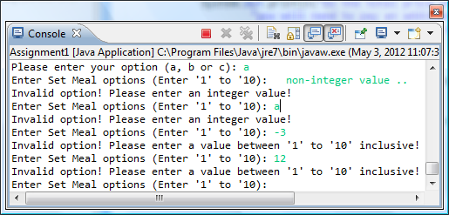

Number of regular/large size meal

1. Must be an integer
2. Must be between 0 to 10 inclusive

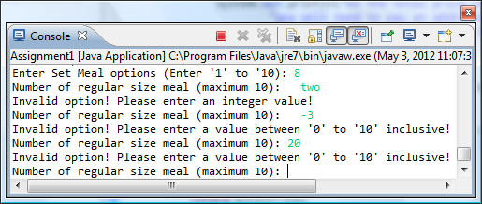

Number of side-dishes for regular/large meal

1. Must be an integer
2. Must be between 0 to 3 inclusive

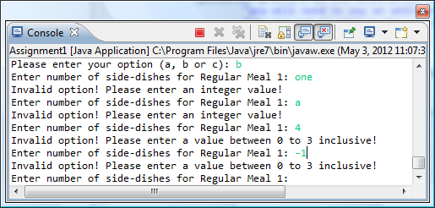

Side-dish option

1. Must be an integer
2. Must be between 1 and 3 inclusive

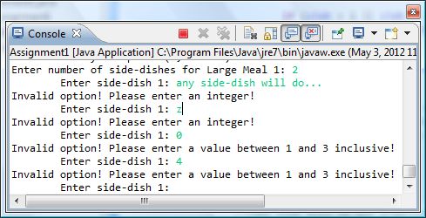

Option 3: Enter username

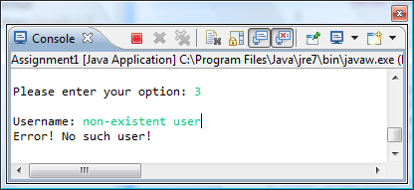

username must exist in records

Option 3: Enter password

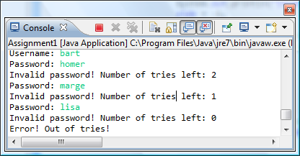

3 tries given to enter password

Option 4: Enter username

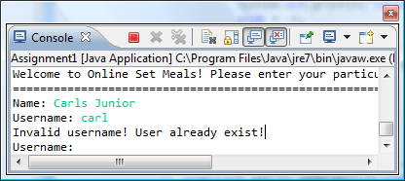

new username must be unique

Option 4: Enter contact number

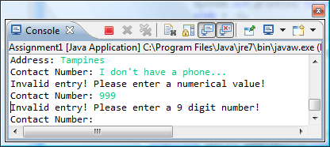

Must be a 9 digit numerical value

Delivery/Collection:

Date

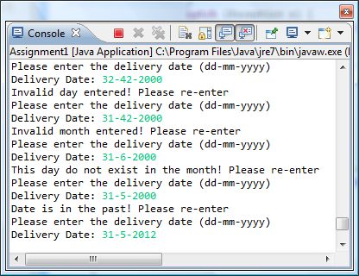

Time

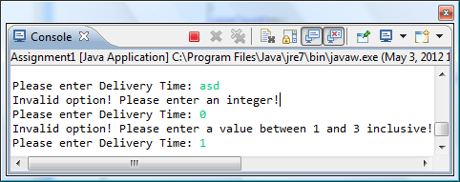

Confirm/Change

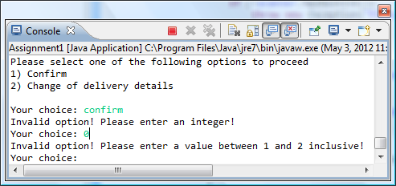

Option 5: Enter order ID

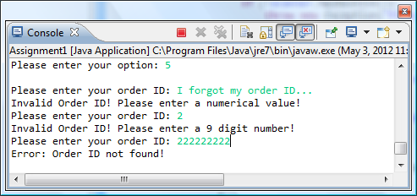

Other Comments

The program handles errors made when entering data of a different type then what it is required

When entering strings like username, password or order ID, the leading and trailing white spaces are trimmed so that user can enter white spaces before and after the input data.

Explanation of generateOrderID() function:

* First of all, the program will keep track of the integer value of the order ID of the next order to be made.
* By default, it is 1.
* To ensure uniqueness of order IDs, what this function does is that it goes to the text file containing all the orders (“orderData.txt”) and gets the order ID with the largest value.
* The order ID of the next order (which the program keeps track of) will be the largest order ID found plus 1.

**Areas that can be improved**

The way of entering the set meals only allows for one type of main course per order. It can be changed to allow multiple types of main courses in an order.

When entering the password, every character keyed in can be replaced by a ‘*’ or some other character so that the password cannot be seen.

Instead of storing data into text files, we can use a database to handle our information. This adds a layer of security and makes it easier of access data.

We could use GUI to make the system more attractive.

I could also add an option in the main menu to allow customer to change their personal information.